**Personas:**



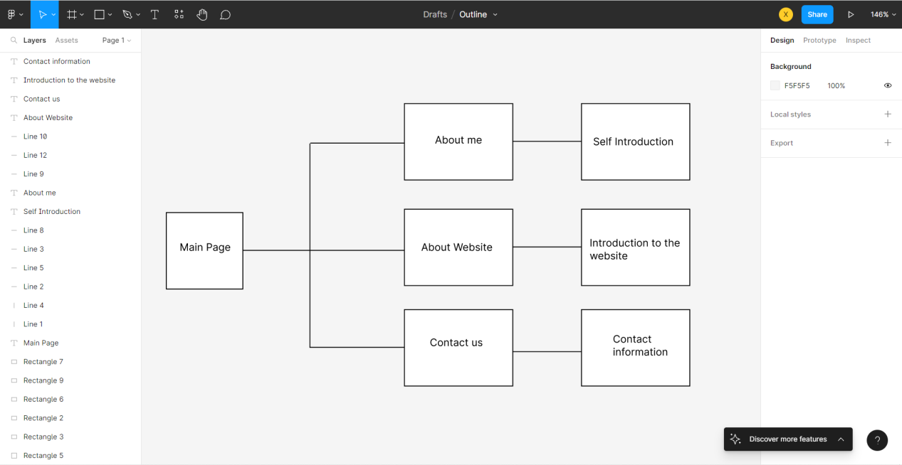

This is the outline of my website, I plan to make four valid HTML5 pages. In these four pages, I will make a navigation, which allows users to easily switch between these four pages. The first page is “Main Page”. In this page, I will introduce myself briefly. The second page is “About me”. In this page, I will share some personal information like, hobbies, and Interests. The third page is “About Website”. I will explain the purpose of creating this website, its use and future development. The last page is “Contact us”. I will collect the names and contact information of people who want to talk to me.

**Wire-frames for website:**

For the main page, I will create 4 navigation on the top. Then, I will upload the my picture on the left side. The right side will be the text box to write brief introduction.

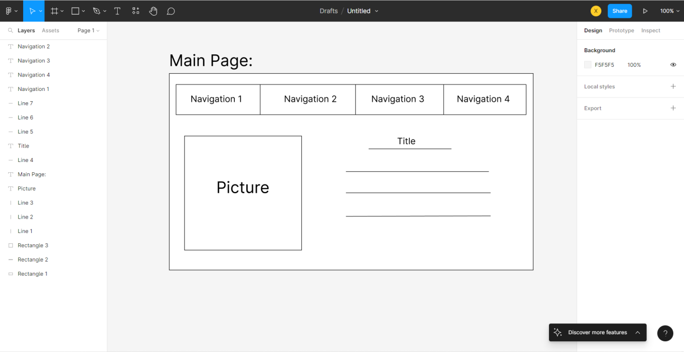

For the “About Me” page, in order to match the style of my every website. I also create four navigation on the top. Then, I will put my own picture on the left side. The right side will be my personal information like, interest, hobby, or my personal stories.

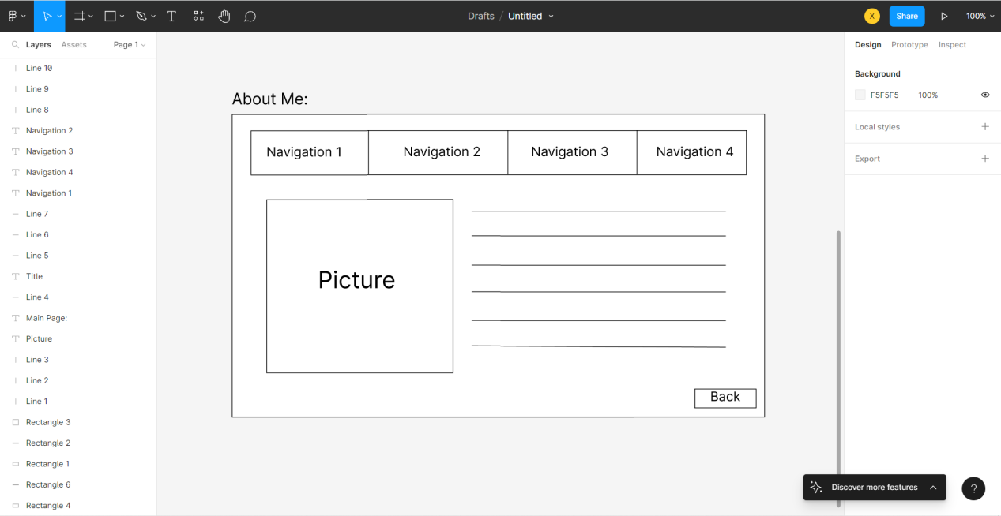

For the “About website”, I will create four navigation on the top which can match my website style. Then, I will put “Good Web” logo on the right side. I will write down some introduction on the left side.

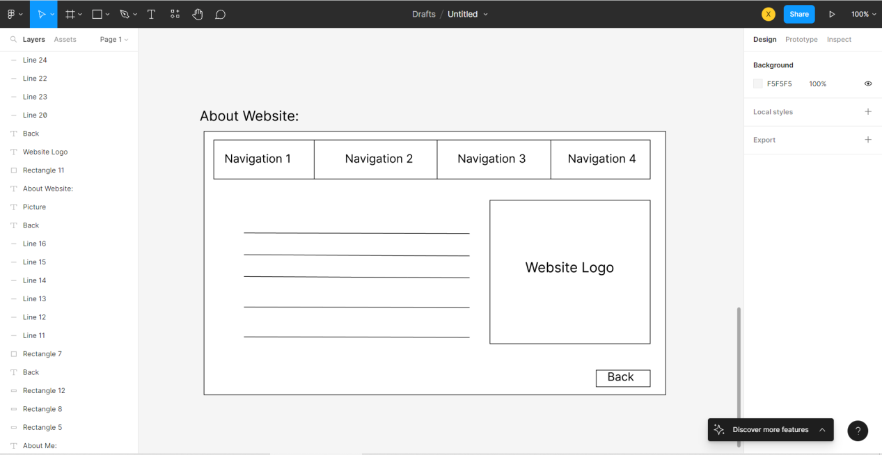

About “Contact Me”, I will make four navigation. Then, I will use five rectangular boxes for the users to write down their contact information like first name, last name, email, phone number, and reasons to contact me. In the end, I will make a submit button.

